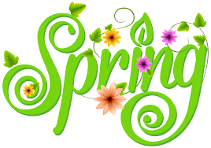

Please refer to the following schedule for the week of April 6th. Understandably, we know many of you are celebrating the holiday; therefore we tried to incorporate a fun activity to help ignite some creativity! Additionally, if there is any work that your child needs to complete from the week before, please use this week to get caught up!

* **STEAM Project**: Students will follow the link below to create something out of recycled materials. They should read the directions for the project and submit a PICTURE of their final product

**NO LATER THAN APRIL 13th**!

* **Discussion Questions**: Each day student will login to the “Discussion Post” on Mrs. Goodrich’s homepage to respond to a journal response question. Please check back for her response to your post as a way to notify you she has read and received it.
* **SUMDOG Log**: Students are expected to download the Sumdog log and use it to record date, topic, title, and total number of minutes practiced on a daily basis. You are required to log in daily and practice for at least 30 minutes on a topic we covered already in class or set up competitions between you and some of your classmates. Mrs. Faour is expecting to see 7 topics recorded on your log before you submit it. You can submit it by email to: [lfaour@yonkerspublicschool.org](mailto:lfaour@yonkerspublicschool.org)
* **BrainPOP**: Students will login to BrainPop and complete their Social Studies topic for the week. They will complete the activities that have been chosen after viewing the informative video.

Should you have any further questions, please do not hesitate to contact Mrs. Faour or Mrs. Goodrich. We look forward to viewing some interesting STEAM projects!